README
This documentation is written for the accessibility of both researchers and programmers alike. If you are experienced with programming and coding, it is best to just go directly to the section Brief Directions to Run Cleaner on Pleabargains Data. The data cleaner cleanData.py, known as the script, is written in the Python programming language and requires Python 3 installed in order to run. Due to the nature of the Pleabargains experiment, the survey flow is broken up to multiple parts for each participant due to the animation redirecting a participant to-and-from the Qualtrics website. The data is exported typically as a .csv file, where the data for each participant will occupy multiple rows, sharing a parameter called Response ID, or RID, across these rows. This script will attempt to combine all rows with the same RID together.

Materials
In order to run the cleaner, you will need to use Command Line on a computer to navigate to the folder containing the files.

Files:
To clean the data, the following files will be needed:
- cleanData.py
- name_of_your_input_file.csv
At most, 2 output files will be generated. These can be generated with a desired name within the code:
- output_file.csv
- output_file_deleted.csv
  - This file is currently generated with responses filtered out to a separate output file that have “123456” entered as the unique participant identification, typically done for testing purposes.
  - Additional conditions may be added (such as if the participant completed the experiment fully) in the main body of the code of cleanData.py with experience in writing in Python.

Properties:
There are some properties of the data that you will need before running the cleaner. These will correspond to mutable values found at the beginning of the script:
- The name of the csv file
- The name of the two variables that refer to the unique participant identifier.
  - In the beginning and end of the survey, there is a field that participants enter in order to uniquely identify themselves.
- Whether or not the data recorded will have 3 rows of headers, or 2 rows of headers.
  - This is particularly focused on the design of survey flow. Within participant studies will typically have 2 rows of headers. Data from other experiment designs may have 3 rows.
Note: an important property to note is that the variable header within the data must have unique names. If there are two different columns that are labeled “ParticpantName”, then the script will not be able combine the rows correctly. If this were to happen, a notice will pop up when running the script.

Procedure
Written for both researchers with and without programming experience, there are both detailed and brief directions available to clean the data. Directions are subject to change depending on changes to accessibility, version of the cleaner, and data of the experiment run.

Detailed Directions to Run Cleaner on Pleabargains Data

Configuring the file
- First download the script and make sure it is in the same folder as the csv file.
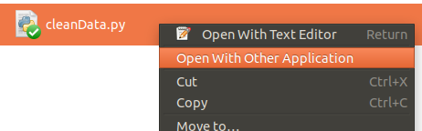Image 1: The right-click menu shows options to open the .py file
Modify the script so that it cleans data from the correct file
- Right click on the script.
- Find an entry or similar to “open with” or “edit with”.
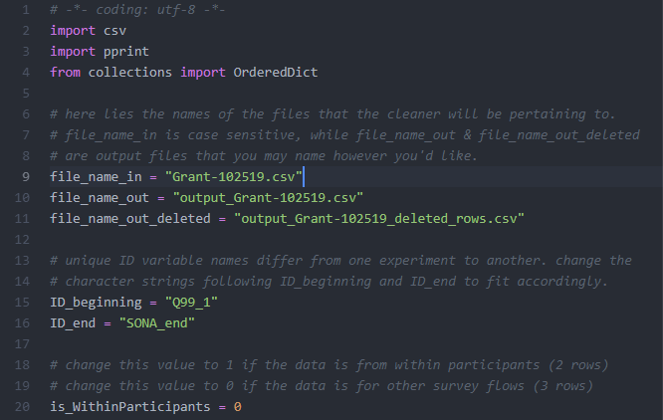
- Find the respective application you would like to open with. Notepad, Text Editor suffices. Atom, and sublime text can be used as well, as they have keyword highlighting.
- With an example shown above, modify the variables such that they are accurate to the desired input/output as well as the properties of the experiment described in Materials: Properties.
- Once the edits have been made to the 3 variables, save the file and exit.

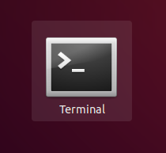
Running the file
Once you have the file and configured the file accordingly. Follow these steps to run the python script. See Downloading and Configuring Python to see steps on downloading and installing python or checking what version you have.
- Open Terminal (Linux, Mac) or Command Line (Windows)
- Navigate to the folder that contains the data cleaner file and CSV data file using “cd” and “ls”(linux/mac) / “dir”(windows).
  - In Terminal/Command Line, type: cd <full path name of the folder>
examples* include:
OS: | Example in terminal:
Windows | cd C:\users\
Linux, Mac | cd /home/marvin/Downloads/
- to run the script once you’re in the respective directory, Type: python cleanData.py
  - NOTE: Type python3 instead of python If you downloaded Python 3 with Python 2 pre-existing on your system.
  - see Downloading and Configuring Python (step 3) if this step gives you an error
- output files will be generated in the same folder based on the names of file_name_out and file_name_out_deleted.
* note: if your file has spaces, you can either encapsulate the whole name of the folder in “quotes” or precede each space character with a “\” backslash character ensuring the space character is read as it is.

Downloading and configuring Python
Make sure you have python version 3.8.1 (this was the version the script was written in. Be wary other versions may not support some features). Here is how to check what version of python you have:
- Open Terminal (Linux, Mac) or Command Line (Windows)
- Type: python --version
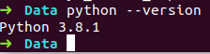Image 3: typing “python --version” will output the version number
  - Download python if you find that you don’t have version 3 of python here. Click the link, find the Download Python button, scroll down to Files, and download the respective version to your operating system.
- This link contains information on configuring the Environment Variable on Windows and other configuration details.

Brief Directions to Run Cleaner on Pleabargains Data
- Download the file and put it in the same folder as the csv file
- Edit the file’s contents such that the following variables are assigned …
  - … the desired file names you want:
    - file_name_in (input file; the data csv file)
    - file_name_out (output file)
    - file_name_out_deleted (output file for test rows ID:123456)
  - … the name of the variable that refers to the participants unique ID :
    - ID_beginning (ID at the beginning of the survey flow)
    - ID_end (ID at the end of the survey flow)
  - … the correct corresponding value (0 or 1)
    - Is_WithinParticipants (change to 0 if csv has 3 header rows, 1 if it has 2 header rows)
- Open the Command Prompt / Terminal and navigate to the folder containing the script.
- Run the file by typing “python cleanData.py”
- Look in the same folder for the output files.
Repeat the editing step (step 2) for each time you need to clean more data.

Script Logic

What the script will do
The script will attempt to clean exported .csv files generated from Qualtrics by combining multiple rows of the same LinkID together by way of updating key:value pairs in a ordered dictionary data structure. There will be instances where data is present in more than one of these rows with the same LinkID. In these cases, data in the first row is written into the output file, and data from the same column of further row will not be written to the output file.
Here are the names of columns where exceptions are explicitly made, or have some special behavior associated with them:
Column Name (Exact String) | Behavior / Interaction with the data
“LinkID” | The script will find the LinkID across rows and attempt to merge data between the two rows. Data from the first row will be written to the output file; this includes redundant values of the same column but also data where the values of the same column are different. Below are columns where there are exceptions to this behavior.
“email” | The script will combine values from the rows and remove the comma because data from this row is typically a single comma or the full email address. The resulting string will be written to the output file.
“Duration (in seconds)” | The script will add all values from all the rows together and write the total to the output file.
ID_1 or ID_2 | The script will check these values if they are “123456” and save the whole LinkID to a separate data structure dedicated to test entires. If this data structure is populated, then a second output file will be created, populated with entries where this variable’s value is “123456”

